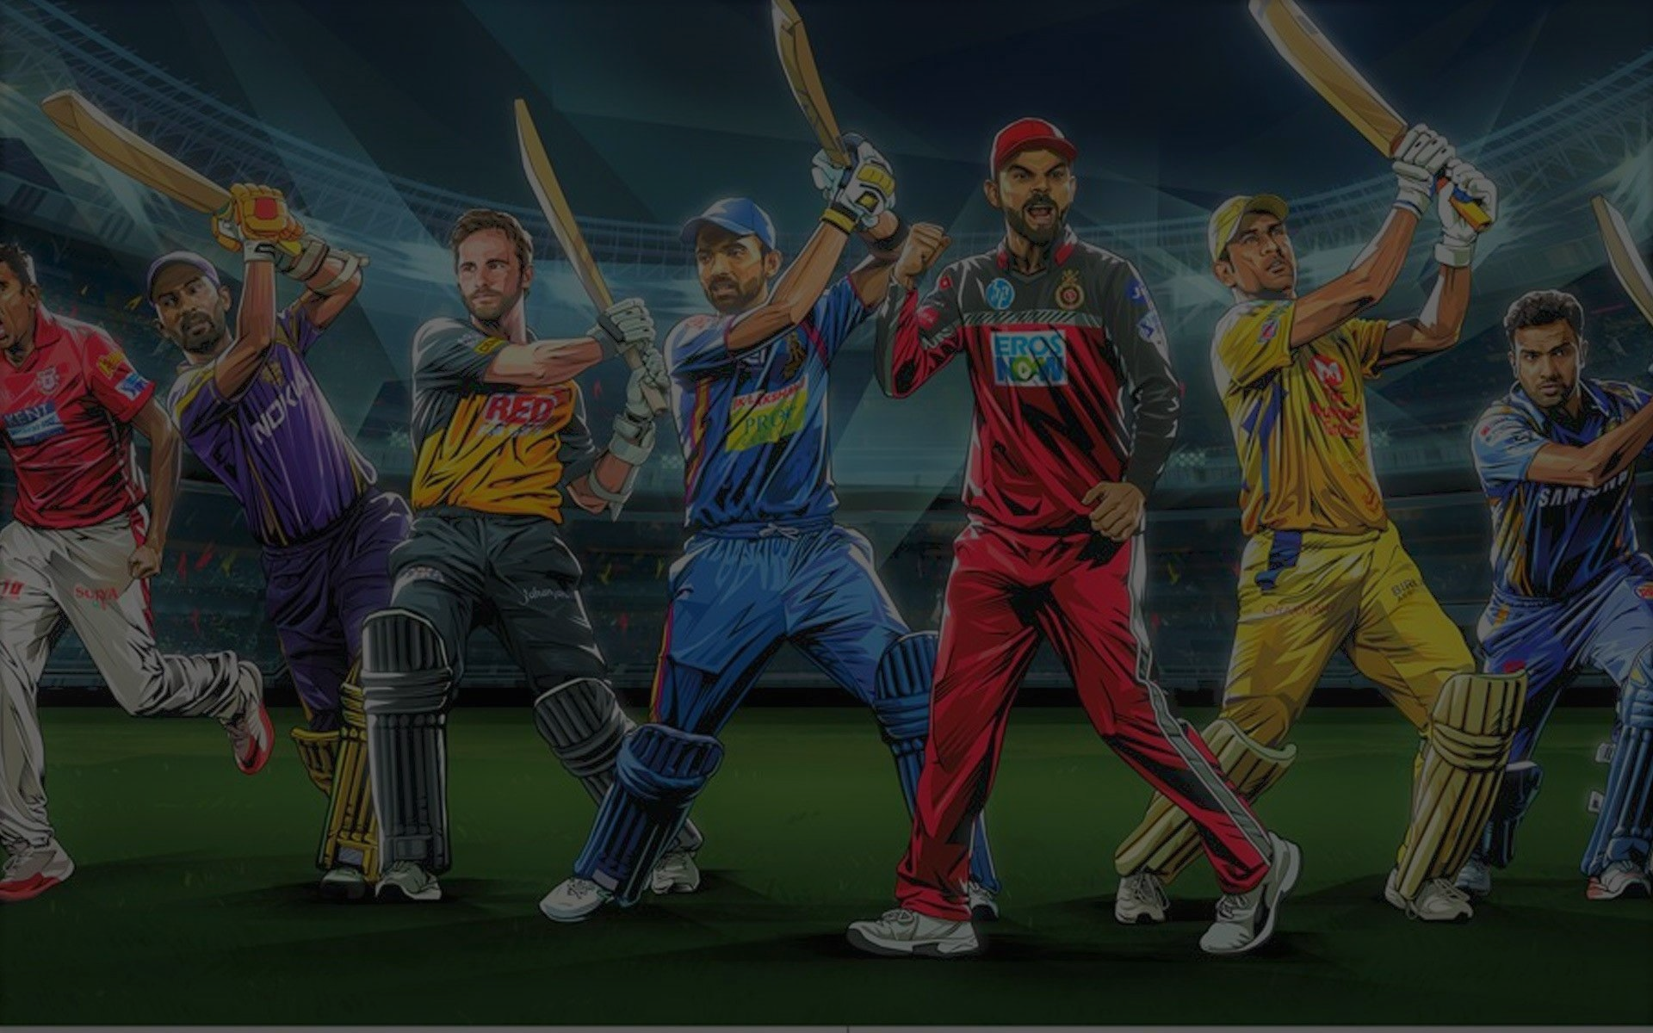

**IPL ANALYTICS - RCB STRATEGY**

**By Nikhil Mohanty**

Objective Questions

1. **List the different dtypes of columns in table “ball_by_ball” (using information schema)**

**Ans.**

Using the above mentioned query we can fetch column details using information schema of the ‘ball_by_ball’ table

*Approach:* The column information could be fetched by two methods, either by using ‘**describe ball_by_ball**’ or fetching the details from information_schema like ‘**SELECT COLUMN_NAME, DATA_TYPE**

**FROM information_schema.Columns**

**WHERE TABLE_NAME = 'ball_by_ball'**

**AND TABLE_SCHEMA = 'ipl';’**

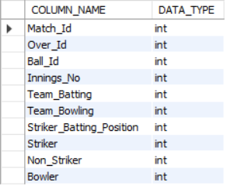

1. **What is the total number of run scored in 1st season by RCB (bonus : also include the extra runs using the extra runs table)**

**Ans.**

In Season 1 RCB scored a total of 1911 runs distributed by 1865 runs scored in batting. The remaining 46 runs have been acquired by extras.

*Approach:* The runs have been fetched by calculating the runs scored in every ball using the ball_by_ball table joining the batsman_scored table where Team_batting attribute of ball_by_ball table is filtering records of only RCB. Using left Join the extra runs table is connected and joining it to the matches table we get the season_id and aggregating the **runs_scored + extra_runs** by summing it up and grouping by season_id we get the Runs scored by RCB in all seasons of IPL.

(The tables ball_by_ball, batsman_scored, extra_runs have been joined by 4 attributes : **match_id and over_id and ball_id and innings_no** )

*Insights:* Season 1 is the least scoring season for RCB.

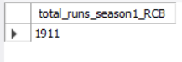

1. **How many players were more than the age of 25 during season 2 ?**

**Ans.**

A total of 194 players were playing in the season 2 of IPL who can be considered as youngsters (<25 years of age).

*Insights:*

* Out of a total of 469 players playing is season 2 of IPL 194 were of the age more than 25 years of age which is 41.36 % of the total players.
* Total 58.64 % of young players (<25 years of age) were playing in the season 2 of IPL.

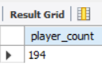

1. **How many matches did RCB win in season 1 ?**

**Ans.**

Despite having star players like Rahul Dravid, Virat Kohli, Anil Kumble RCB showed a very loose performance in Season 1 of IPL.

*Insights:*

* RCB has won a total of 4 matches out of 14 matches in season 1 with a winning percentage of 28.75%.
* In season 1 RCB scored the least number of runs which is **1865** considering all seasons of IPL.



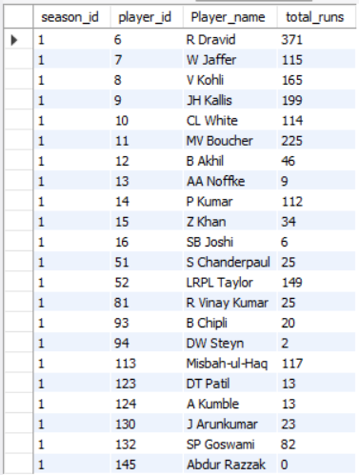

1. **List top 10 players according to their strike rate in last 4 seasons**

**Ans.**

The listed 10 players showed the maximum strike rate in the last 4 seasons as per the runs they scored divided by the balls they played.\

*Approach*: The Strike_rate is calculated by dividing the total runs scored by the player by the total balls they played.

For this we used the ball_by_ball table joining it with the batsman_scored table, matches table. Grouping it by the striker name we can aggregate the strike rate using ‘**round(100*(sum(runs_scored)/count(b.ball_id)),2) as strike_rate**‘

The output query is filtered to only last 4 seasons using subquery.

*Insights:*

* The list is topped by **RV Gomez**, followed by **AN Ahmed** and **CR Brathwaite** in the top 3 positions.

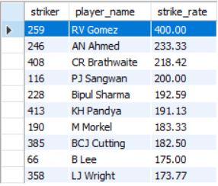

1. **What is the average runs scored by each batsman considering all the seasons?**

**Ans.**

The Average runs scored by each batsman considering all seasons is in the list below.

*Approach:* The average runs is calculated by joining ball_by_ball table with the batsman_scored table, matches table and players table grouped by player_id and aggregating sum(runs_scored) and dividing it with the distinct matches played to get the average of the Batsman.

The query is ordered by the descending order of the average visualising the batsman with highest averages in the IPL.

*Insights:*

* From the table we can interpret that players with highest averages are LMP Simmons, CH Gayle & SE Marsh.
* We can verify 3 star players(CH Gayle, Virat Kohli & AB De Villiers) from RCB in the top batsman list yet they were unable to win an IPL trophy.

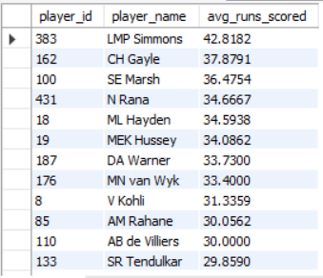

1. **What are the average wickets taken by each bowler considering all the seasons?**

**Ans.**

The average wickets taken per season by all bowlers is calculated as per the definition and a small part of the resulting query is displayed below.

*Approach:* The Average wickets taken per season is calculated by aggregating the sum of wickets taken by bowlers and dividing it with the number of seasons in IPL to get the average wickets taken per season.

For this the ball_by_ball table is joined with wickets_taken table, matches table and player table.

*Insights:*

* The List of highest wicket takers is topped by SL Malinga, DJ Bravo and A Mishra.
* In the Top 10 list 4 of the bowlers are spinners while rest of them are medium fast or fast bowlers.

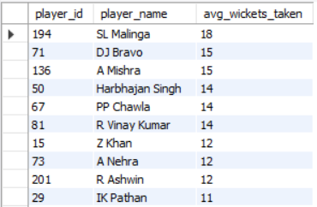

1. **List all the players who have average runs scored greater than overall average and who have taken wickets greater than overall average**

**Ans.**

-- -- For players having more than the avg runs per season

***Insights:***

* We could see LMP Simmons, CH Gayle & SE Marsh topped the list.
* Top RCB Batsman CH Gyale and Virat Kohli also on the Top 10 List.

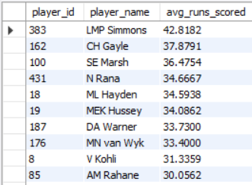

-- -- For players having more than the avg no of wickets per season

*Insights:* The highest bowling average is calculated per season by dividing total no of wickets taken by the number of seasons.

* We can visualise that SL Malinga, DJ Bravo and A Mishra topped the list
* Only R Vinay Kumar from the list is from RCB.

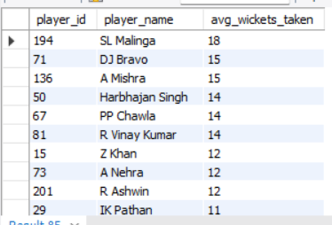

1. **Create a table rcb_record table that shows wins and losses of RCB in an individual venue.**

**Ans.**

Table named rcb_record table is created that shows the wins and loses of RCB in all the venues.

*Approach:* First we fetched the wins and lost data of RCB from the matches table and venue table by filtering the match_winner as RCB for the wins column and using where match_winner <> RCB for the lost column.

Grouped by venue we aggregated sum(wins) and sum(Lost) for the table.

A new table named rcb_record created by taking venue Id as the primary key and columns venue_name, Wins & Lost and the data fetched from the above query is inserted into it.

We can use ‘**select * from rcb_record**’ to visualise the table.

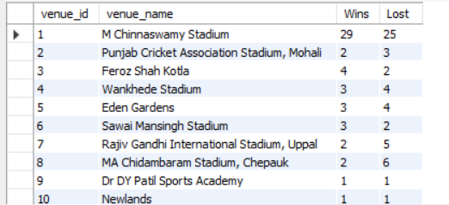

1. **What is the impact of bowling style on wickets taken.**

**Ans.**

We can analyse the data of wickets taken and number of overs bowled of respective bowling_style.

* Right arm medium bowling style tops the list in taking wickets as well as overs bowled with an average wicket of 1.18 per over.

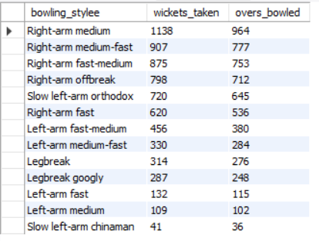

1. **Write the sql query to provide a status of whether the performance of the team better than the previous year performance on the basis of number of runs scored by the team in the season and number of wickets taken**

**Ans.**

------------- For batting -------------

*Approach:* From the calculated table of season_id and runs for RCB we used lag() function to detect the change in runs percentage as per the previous season scores.

*Insights:*

* From the table we could visualize that there a huge change in the percentage in season 2, season 7 and season 9
* In season 2 the increase in percentage change of scores in 16.14 which is a very positive sign of score improvement. Meanwhile in Season 7 there’s a huge dip of 19 % in runs scored from the last season depicting huge performance loss of RCB
* In season 9 RCB gained a huge advantage of gaining 30% than the last year scores and that is the season where RCB went into the finals.

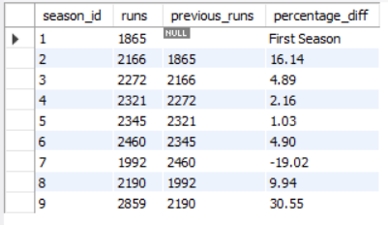

------------- For bowling -------------

*Approach:* From the calculated table of season_id and wickets_taken for RCB we used lag() function to detect the change in wickets_taken percentage as per the previous season wickets.

*Insights:*

* From the table we could visualize that there a huge change in the percentage in season 3 and season 10
* In season 3 the decerease in percentage change of scores was 18.87% which is a very drastic dip in the wickets taken. Meanwhile in Season 9 there’s again a huge dip of 10 % in wickets_taken from the last season depicting huge performance loss of RCB

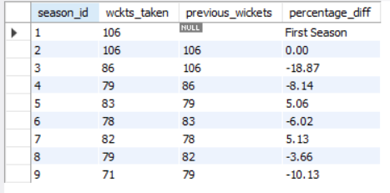

1. **Can you derive more KPIs for the team strategy if possible?**

**Ans.**

1. Win Loss record:
   1. The winning percentage of RCB is the ratio of matches won and the total matches played.
   2. Winning percentage is depicted by a line chart below.

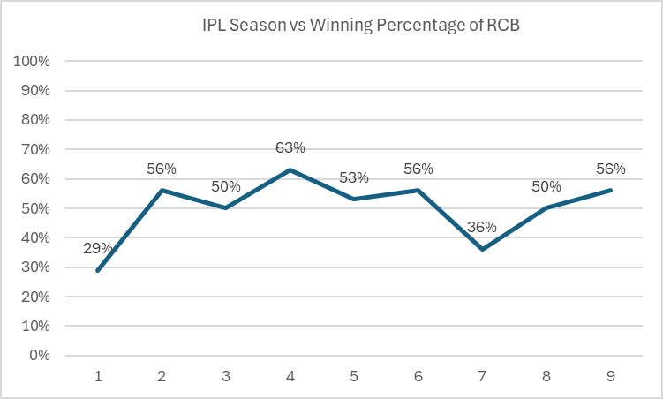

1. Average runs per match:
   1. The average score of RCB per match in all seasons of IPL could be a nominal KPI to assess the match performance.



1. Average wickets taken per match:
   1. Average Wickets taken by bowlers in each match can be used as a KPI.



1. **Using SQL, write a query to find out average wickets taken by each bowler in each venue. Also rank the gender according to the average value.**

**Ans.**

The bowlers ranked as per the average wickets taken at the venue.

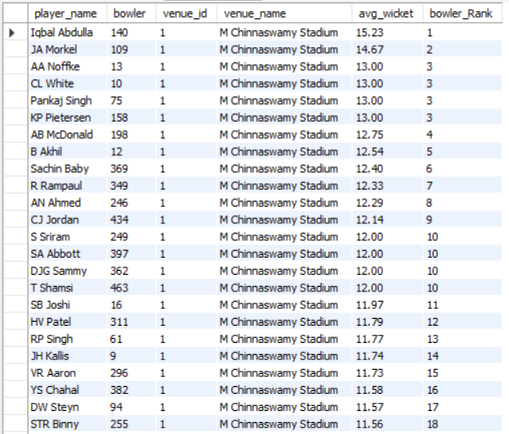

1. **Which of the given players have consistently performed well in past seasons? (will you use any visualisation to solve the problem)**

**Ans.**

The list below mentions the players of RCB and the runs they scored in the last 3 seasons to compare their performance.

*Insights:* From the column chart it is quite evident that Virat Kohli, AB de Villiers & Chris Gayle have maintained consistency in scoring runs in the past 3 seasons.

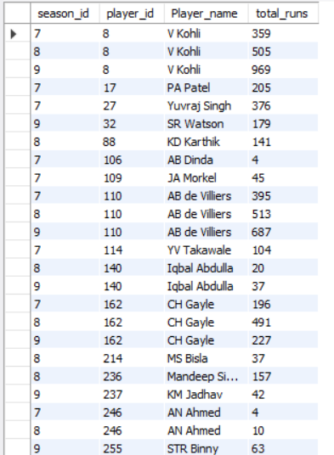

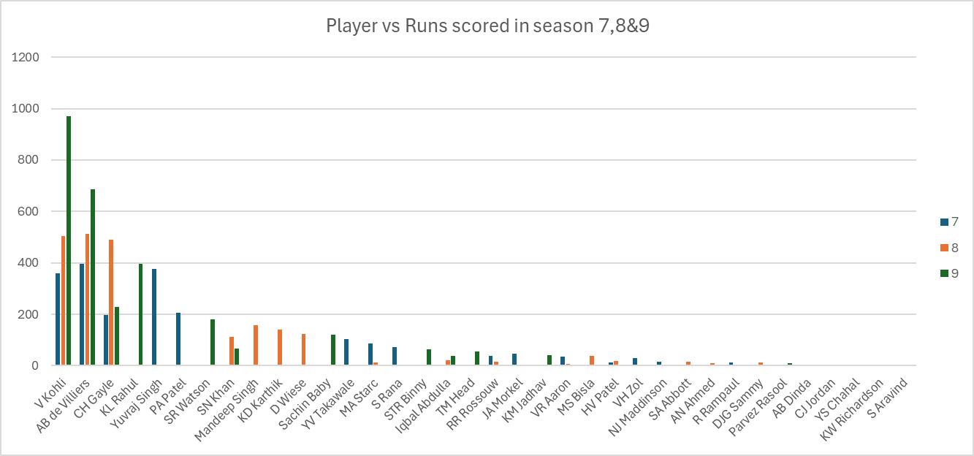

Runs made by batsmen in the last 3 seasons.

1. **Are there players whose performance is more suited to specific venues or conditions? (how would you present this using charts?)**

**Ans.**

The average_runs scored by batsman at the respective venues have been shown below in the list.

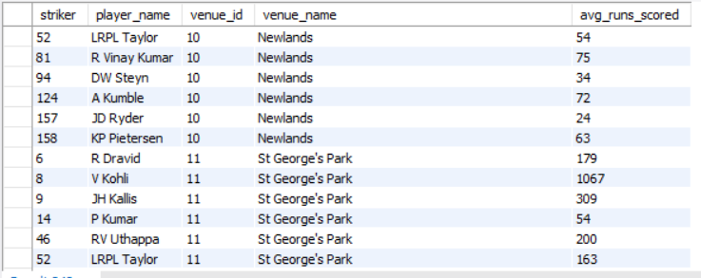

**Subjective Questions**

1. **How does toss decision have affected the result of the match ? (which visualisations could be used to better present your answer) And is the impact limited to only specific venues?**

**Ans.**

*Approach:* To get the effect on toss decision with match results we considered joining the matches table with the toss_decision table and lastly joined the venue table to get to know about differences in the toss decision in match results across the venues.

*Insights:* From the results being grouped by Match_won_by_toss_winner and Match_won_by_toss_loser we couldn’t derive much of a difference as both have almost equal percentage of share.

* The percentage of toss winners who won the match is 51 % concluding the toss decision have very less relevance in actual match results.
* The percentage of toss losers who won the match is 49% concluding that the analysis of the ground parameters are not quite right by the toss winner team due to which despite winning the toss they still tends to lose they matches.



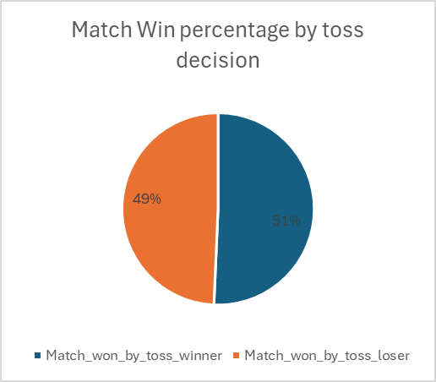

The following table shows the toss_decision results and the actual match results throughout all the venues.

* Since only the top 8 venues show a distinctive amount of matches held in them, we considered those 8 venues to be projected in the column chart for the pictorial representation.

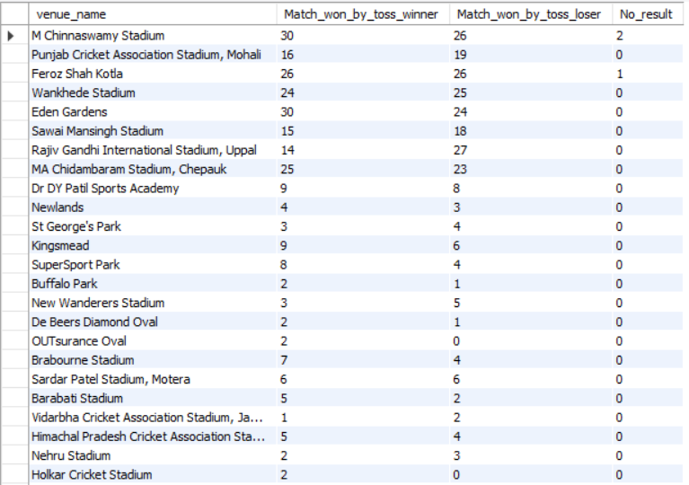

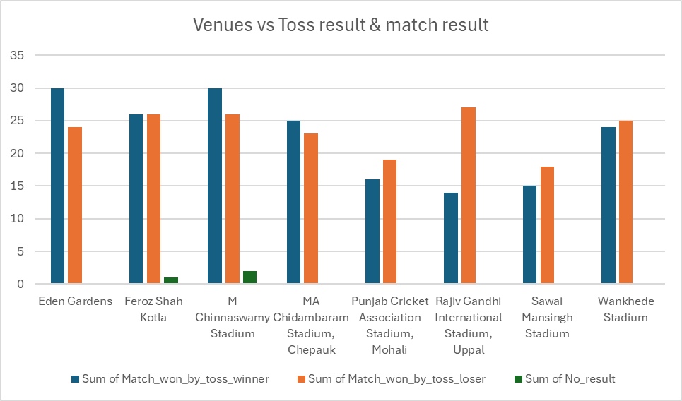

1. **Suggest some of the players who would be best fit for the team?**

**Ans.**

*Approach:* For suggesting players to RCB we would categorise the players into batsman or bowler as well as would consider the young players(<27 years of age) to maintain the good fielding approach for the team.

Suggestion of players based on the specific predefined criterias:

* **Batsman:** We have used the ball_by_ball table joined with the batsman_scored table and further joined with the player table.To calculate the average runs we used the formula: ***Total_runs_scored/Total_matches_played.***

To calculate the strike rate we used the formula: ***Total_runs_scored/Total_balls_played***

The top 10 best batsman according to the results are mentioned below in the table

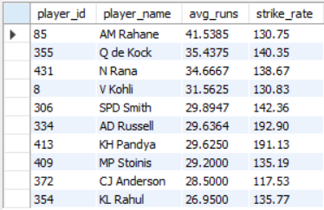

*Insights:* We could visualise great potential of AM Rahane, Q de Cock and N Rana to be performing very well across all the seasons with maintaining an average runs of more than 30 and a strike rate of more than 130 which can be considered very impressive for the young talents.

*Recommendations:* It is to be advised to RCB to acquire those top charter young players for their middle order batsman segment to perform well in the next season.

* **Bowler:** We have used the ball_by_ball table joined with the wikcets_taken table joined and further joined with the player table.To calculate the wickets taken we used the formula: ***sum(wickets_taken)***

To calculate the bowling_average we initiated an cte in which the ball_by_ball table is joined to the batsman_scored table grouped by the bowler’s Id from which we aggregated the total number of runs given by the bowler and we **concatenated the match_id and over_id attribute to uniquely determine the overs**. To calculate the Bowling average used the formula: ***Total_runs_given/Total_overs_bowled***

The top 10 best bowlers according to the results are mentioned below in the table

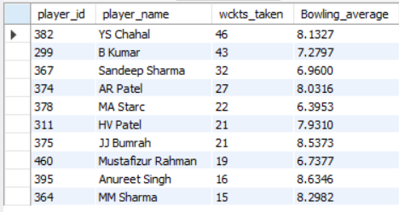

*Insights:* We could visualise great potential of YS Chahal, B Kumar and Sandeep Sharma with wickets taken over 30 in all the seasons they played and a bowling average of less than 8.5 runs per over which is an impressive parameter.

*Recommendations:*  It is to be advised to RCB to acquire those top charter young players for their death bowler segment to perform well in the next season.

1. **What are some of parameters that should be focused while selecting the players?**

**Ans.**

Parameters that should be focussed while selecting the players are:

**Skill Level and Expertise**:

* Proficiency in sport-specific skills.
* Experience in similar competitive settings.

**Physical Fitness**:

* Endurance and performance sustainability.
* History of injuries and their impact.
* Speed and reaction time.

**Performance Metrics**:

* Recent performance trends in competitions.
* Consistency in delivering strong performances.
* Key statistics (e.g., average score, strike rate, wickets taken).

**Positional Versatility**:

* Ability to play multiple positions as needed.
* Specialisation in a key role for team strategy.

**Tactical Awareness**:

* Knowledge of game strategies and tactics.
* Situational awareness and adaptability during play.

**Impact on Team Morale**:

* Ability to uplift team spirit and cohesion.
* Compatibility with the team’s culture and values.

1. **Which players offer versatility in their skills and can contribute effectively with both bat and ball? (can you visualize the data for the same)**

**Ans.**

*Approach:* To analyze the versatility of the players we consider two factors i.e. the average runs scored by the player and average wickets taken by the player to determine their all rounder advantages.

* To obtain the desired results we used two CTEs:

One for the Batting average where we took ball_by_ball table joined with batsman_scored table, matches table & player table grouped by striker_id and player name and aggregated the **runs_scored/total matches played** to get the average runs.

The next CTE is used for the average_wickets_taken by the players using ball_by_ball table, wickets_taken table, matches table and player table where we aggregated the total number of wickets taken / total_matches_played

Finally we joined both the CTEs and derived the player_id, Player_name, Avg_runs & Avg_wickets from the CTEs.

*Insights:* We could visualisew that players like KH Pandya, MP Stoinis, RG Sharma, SR Watson & DR Smith have an average of more than the overall Batting average and also got the average wickets more than 1.5 which determines the versatility of the players.

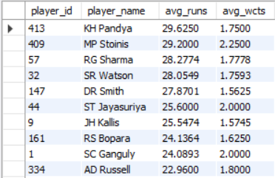

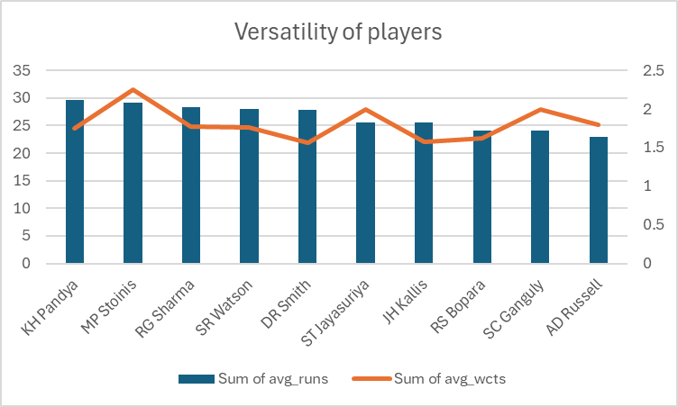

1. **Are there players whose presence positively influences the morale and performance of the team? (justify your answer using visualisation)**

**Ans.**

*Approach:* Here we are considering star batsmen Virat Kohli & AB De Villiers for their influence in winning games of RCB in season 7,8 & 9 of IPL.

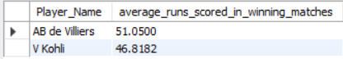

*Insights:* As we can visualise that Virat Kohli and AB Devilliers have an incredible average in the winning games of RCB depicting high performance value and enriching morale of the team.

RCB showed an improvement in season 8 & 9 where the winning percentage increased to 50 & 56 respectively due to these star players supporting their team.

1. **What would you suggest to RCB before going to mega auction ?**

**Ans.**

**1. Strengthen the Bowling Attack**

#### **a. Focus on Death Bowlers**

* Acquisition Target: Look for bowlers with proven records in the death overs. Consider players who have consistently performed well in high-pressure situations.
* Examples: Look at players like Dwayne Bravo, Lasith Malinga, or young talents like Jasprit Bumrah.

#### **b. Variety in Bowling**

* Ensure a mix of pacers and spinners to adapt to different pitch conditions. Consider acquiring all-rounders who can bowl as well.
* Example: Players like Ben Stokes or Shakib Al Hasan offer both batting and bowling options.

### **2. Enhance the Middle Order**

#### **a. Middle-Order Stability**

* Target middle-order batsmen who can play under pressure and maintain a high strike rate. This will provide depth in batting and reduce reliance on star players.
* Examples: Players like Kedar Jadhav or Ravindra Jadeja could be valuable additions**.**

#### **b. Flexibility in Batting Order**

* Look for players who can bat in multiple positions, allowing for better tactical adjustments during matches.

### **3. Focus on Fielding and Fitness**

#### **a. Fielding Specialists**

* Invest in players known for their exceptional fielding skills to minimize errors. Good fielding can save crucial runs and change match dynamics.
* Examples: Players like Kieron Pollard or Jasprit Bumrah are known for their agility and fielding prowess.

#### **b. Incorporate Fitness Training**

* Emphasize fitness and injury prevention to maintain player availability throughout the season. Hire specialized trainers if needed.

### **4. Assess Team Chemistry and Culture**

#### **a. Team Dynamics**

* Consider the chemistry between players. Look for players who can gel well with existing stars like Virat Kohli and AB de Villiers.
* Team Culture: Build a strong team culture that promotes camaraderie and mutual support.

#### **b. Leadership Roles**

* Identify potential leaders within the squad who can take on additional responsibilities. Consider backup leadership options in case of injuries to key players.

### **5. Leverage Data Analytics**

#### **a. Performance Metrics**

* Utilize data analytics to evaluate player performances in various conditions. Assess past IPL data to identify players with consistent performances.
* Statistical Analysis: Focus on metrics such as batting averages, strike rates, bowling economy rates, and fielding stats.

#### **b. Player Compatibility**

* Analyze how potential signings fit into the existing team structure, both in terms of playing style and personality.

### **6. Strategic Spending in the Auction**

#### **a. Budget Allocation**

* Prioritize spending on critical areas (bowling and middle-order) while being mindful of the budget. Avoid overspending on high-profile players without proven IPL success.

#### **b. Smart Signings**

* Look for emerging talents and international players who may not be marquee names but have high potential. Focus on players with good IPL records or those coming off strong domestic performances.

### **7. Identify Key Retentions**

#### **a. Retain Key Players**

* Ensure that the core players like Virat Kohli, AB de Villiers, and Yuzvendra Chahal are retained as they provide both performance and experience.

#### **b. Evaluate Other Retentions**

* Analyze performances of other players and make informed decisions about retentions based on past contributions and future potential.

### **8. Pre-Auction Research and Mock Auctions**

#### **a. Research Players**

* Create a list of players based on performance metrics, fit for the team, and potential impact. Research player availability and interest.

#### **b. Conduct Mock Auctions**

* Simulate the auction process within the management team to strategize effectively and evaluate different scenarios.

1. **What do you think could be the factors contributing to the high-scoring matches and the impact on viewership and team strategies.**

**Ans.**

**Factors Contributing to High-Scoring Matches**

1. **Pitch Conditions**
   * Flat Pitches: Tracks that are even and lack significant assistance for bowlers tend to yield high scores as batsmen can play their shots freely.
   * Good Outfield Conditions: Fast outfields facilitate boundaries, increasing scoring rates.
2. **Powerplay Rules**
   * Fielding Restrictions: The first six overs allow only two fielders outside the 30-yard circle, enabling batsmen to take risks without the threat of catches.
3. **Quality of Batsmen**
   * Strong Batting Lineup: Teams with star power in their batting lineups, such as aggressive openers and finishers, can consistently score high.
   * Innovative Batting Techniques: Batsmen who are adept at playing innovative shots (like scoops and reverse sweeps) can exploit gaps and score runs quickly.
4. **Bowling Quality**
   * Lack of Quality Bowlers: If a team has bowlers who are not effective in T20 formats (e.g., poor death bowlers), it can lead to high-scoring games.
   * Inconsistent Bowling Performance: Frequent no-balls, wides, and poor line and length can inflate scores.
5. **Batting Strategies**
   * Aggressive Intent: Teams adopting an aggressive batting approach, focusing on maximizing run rates rather than preserving wickets.
   * Use of Power Hitting: Emphasis on hitting sixes, especially in the death overs, contributes to higher scores.
6. **Match Situation**
   * Chasing Teams: Teams batting second may score higher due to the need to chase down totals, especially with a clear understanding of required run rates.
   * High Stakes: Matches with playoff implications or rivalries often see higher intensity and scoring.
7. **Weather Conditions**
   * Humidity and Temperature: High humidity can assist bowlers to swing the ball, but on hot, dry days, pitches may become better for batting as the match progresses.
8. **Player Form and Injuries**
   * In-Form Batsmen: Batsmen in good form can capitalize on poor bowling and fielding, contributing to high scores.
   * Injuries to Key Bowlers: The absence of top bowlers can significantly impact a team's ability to restrict runs.

### **Impact on Viewership**

1. **Entertainment Value**
   * High-scoring matches are typically more exciting and entertaining for fans, leading to increased viewership. Spectators enjoy seeing big hits and record-breaking performances.
2. **Media Coverage**
   * Matches that produce high scores tend to attract more media attention, leading to increased engagement and promotion across platforms.
3. **Sponsorship and Advertising**
   * Higher viewership can attract more sponsors, leading to increased revenue for teams and the league as a whole.
4. **Fan Engagement**
   * Engaging content from high-scoring games—such as highlights of impressive innings or record partnerships—can be leveraged for marketing and fan engagement initiatives.

### **Impact on Team Strategies**

1. **Team Composition**
   * Teams may prioritize acquiring aggressive batsmen and dynamic all-rounders to enhance their scoring capabilities.
2. **Bowling Strategy**
   * Teams may invest in versatile bowlers who can bowl in different phases of the innings (powerplay, middle overs, and death overs).
   * Focus on strategic bowling changes and field placements to limit scoring in high-pressure situations.
3. **Batting Orders**
   * Teams may experiment with their batting order to maximize scoring opportunities, such as sending power hitters up the order in crucial matches.
4. **Match Strategies**
   * Teams may adopt a more aggressive approach when batting first, setting high targets that can put pressure on the opposition.
   * During a chase, teams may adjust strategies based on the conditions and the target set, taking calculated risks.
5. **Training and Preparation**
   * Emphasis on fitness, innovative batting drills, and scenarios for high-pressure situations in training sessions to prepare for potential high-scoring encounters.
6. **Analyze the impact of home ground advantage on team performance and identify strategies to maximize this advantage for RCB.**

**Ans.**

**Note:** The home team is decided by the Team_1 attribute in the matches table.

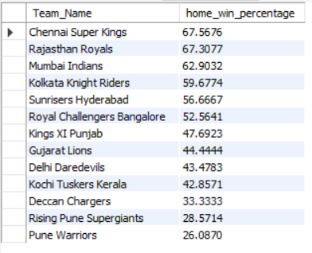

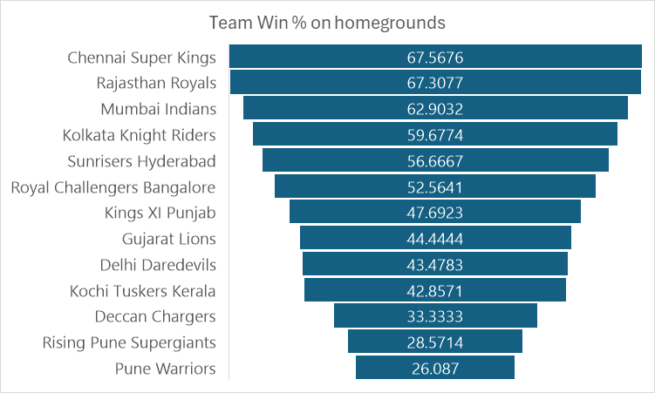

**Impact of Home Ground Advantage on Team Performance**

1. **Familiarity with Conditions**
   * Pitch Behavior: Teams playing at home are usually more familiar with how the pitch behaves over the course of the match. M. Chinnaswamy Stadium is known for its batting-friendly pitches, which tend to favor high scores.
   * Weather Conditions: Understanding local weather patterns can help teams prepare better for different playing conditions.
2. **Fan Support**
   * Increased Morale: Playing in front of a home crowd can boost players' morale and confidence. The enthusiastic support can create a positive atmosphere and encourage players to perform better.
   * Psychological Edge: The presence of home fans can exert psychological pressure on the opposing team, potentially impacting their performance.
3. **Reduced Travel Fatigue**
   * Travel Convenience: Home matches eliminate travel fatigue, allowing players to focus on preparation rather than logistics. This can lead to better performance.
4. **Home Ground Records**
   * Statistical Superiority: Historical performance data may show that teams tend to perform better at home. RCB, for example, has often scored higher at M. Chinnaswamy Stadium than on away grounds.
5. **Pitch and Outfield Knowledge**
   * Local Knowledge: RCB players can leverage their knowledge of the outfield dimensions, boundaries, and hotspots to their advantage during both batting and bowling.

### **Strategies to Maximise Home Ground Advantage for RCB**

1. **Pitch Preparation**
   * Tailoring the Pitch: Work with ground staff to prepare pitches that align with RCB's strengths, favoring batting-friendly conditions that allow their powerful batting lineup to thrive.
   * Understanding Opposition Weaknesses: If an opponent has a weaker batting lineup, preparing a pitch that might assist spinners or seamers could disrupt their game plan.
2. **Fan Engagement**
   * Building a Strong Fan Base: Enhance fan engagement through promotional activities and community events to foster a larger and more supportive home crowd.
   * In-Match Experiences: Create an electrifying atmosphere during matches, such as music, fan zones, and interactive activities, to boost player morale and intimidate opponents.
3. **Local Player Inclusion**
   * Engage Local Talent: Invest in local players who are familiar with the conditions and can adapt quickly to home ground advantages. They may also resonate well with the local fan base.
   * Incorporate Homegrown Players: Players from Karnataka or nearby regions may have better acclimatization and familiarity with local conditions.
4. **Targeted Training Sessions**
   * Practice Matches at Home: Schedule practice sessions and warm-up matches at M. Chinnaswamy Stadium to get players accustomed to the conditions before crucial matches.
   * Condition-Specific Training: Focus on training that simulates the unique conditions of the home ground, including playing in high temperatures and humidity.
5. **Strategic Game Plans**
   * Aggressive Batting Approach: Encourage aggressive batting strategies when playing at home to set high totals. RCB should leverage their power hitters to take full advantage of batting-friendly conditions.
   * Bowlers' Strategies: Develop bowling strategies that target the weaknesses of the opposing team. For instance, deploying spinners during the middle overs can capitalize on the pitch's behavior.
6. **Utilizing Analytics**
   * Performance Analysis: Use data analytics to evaluate past performances at home versus away games to identify patterns and make informed decisions.
   * Opponent Analysis: Analyze opponents' past performances at M. Chinnaswamy Stadium and design strategies accordingly to exploit their weaknesses.
7. **Mental Conditioning**
   * Psychological Preparation: Implement psychological training to enhance players' focus and resilience when playing at home, ensuring they can handle the pressure of expectations.
   * Cohesion Building: Foster team spirit through team-building activities that enhance player relationships and help them feel more comfortable in high-pressure situations.
8. **Come up with a visual and analytical analysis with the RCB past seasons performance and potential reasons for them not winning a trophy.**

**Ans.**

### **1. Overview of RCB’s Performance in IPL**

RCB has been a prominent franchise in the Indian Premier League (IPL) since its inception, but they have faced challenges in clinching the trophy. Here’s a summary of their past performance:

* **Final Appearances**: RCB has reached the IPL finals three times (2009, 2011, 2016) but has not won the title.
* **Position in Standings**: They have finished in the bottom half of the standings in several seasons, despite having star players.

### **2. Visual Analysis: Performance Trends**

To understand RCB's performance trends over the years, we can create the following visualizations:

#### **a. Win-Loss Record Over Seasons**

This visualization shows RCB's win-loss record over the IPL seasons from 2008 to 2016.

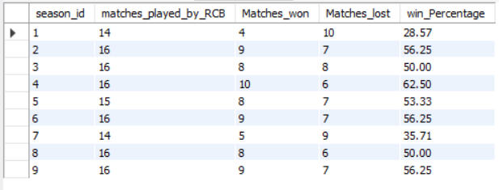

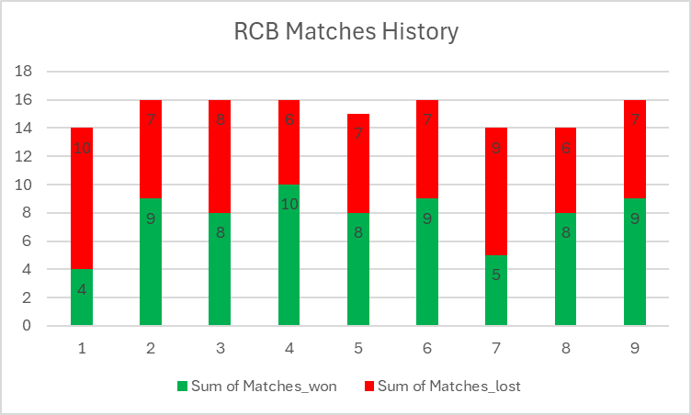

#### **b. Player Performance Analysis**

* **Batsmen**: Virat Kohli, AB de Villiers, Chris Gayle

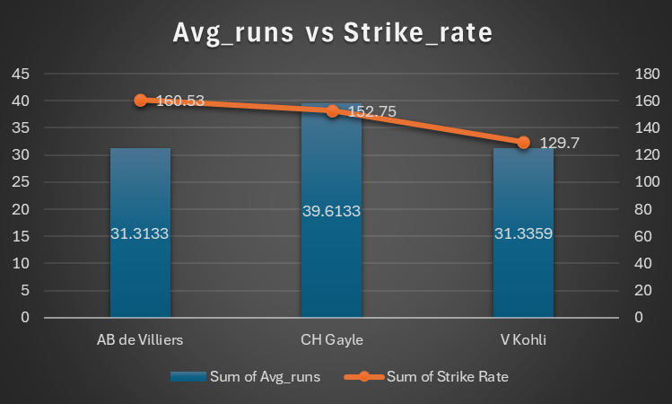

* **Bowlers**: Yuzvendra Chahal, Dale Steyn

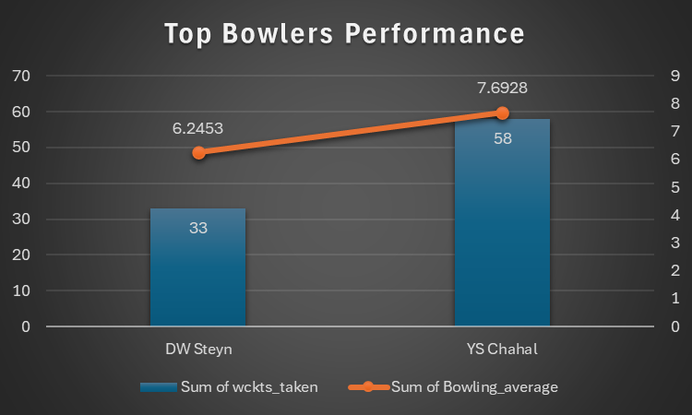

### **3. Statistical Analysis: Key Metrics**

#### **a. Batting Performance**

* **Key Findings**:
  + RCB has historically had strong individual performances, especially from players like Virat Kohli and AB de Villiers.
  + However, they have struggled with depth in their batting lineup, often reliant on a few key players.

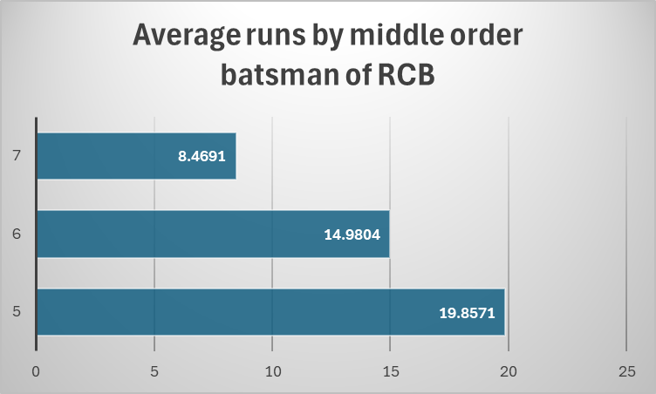

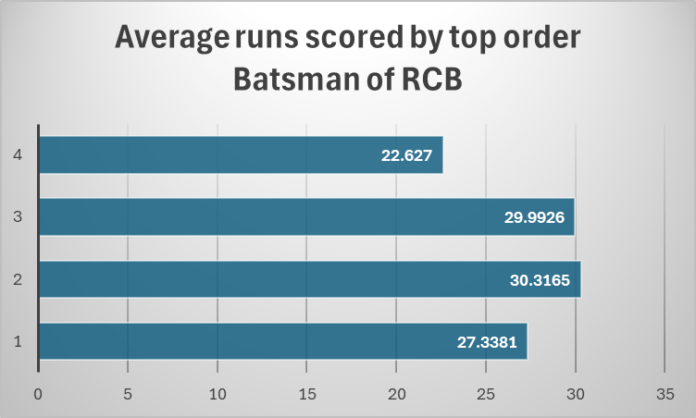

#### **b. Bowling Performance**

* **Key Findings**:
  + RCB’s bowling attack has been inconsistent, often conceding high scores.
  + The team has struggled to defend totals due to lack of depth in bowling options.
  + The economy of bowlers strike down to average 9.3 in death overs

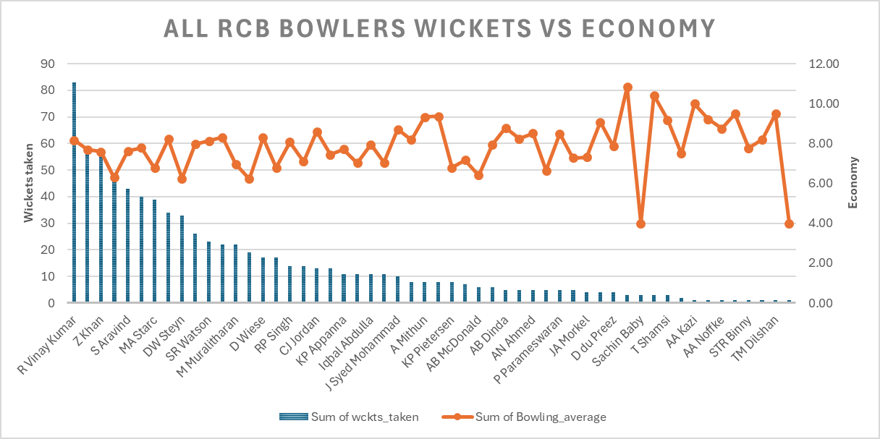



#### **c. Fielding Performance**

* **Key Findings**:
  + RCB has had issues with dropped catches and missed run-out opportunities.
  + Improving fielding could significantly impact match outcomes.

### **4. Reasons for Not Winning the Trophy**

* **Inconsistent Bowling Attack**: Frequent changes in the bowling lineup and lack of quality death bowlers.
* **Reliance on Key Players**: Over-dependence on star players for performance.
* **Poor Fielding**: Consistent fielding errors leading to loss of crucial runs and matches.
* **Match Pressure**: Inability to perform under pressure in knockout matches.

1. **How would you approach this problem, if the objective and subjective questions weren't given?**

**Ans.**

**Without the objective and subjective questions the approach for the analysis would be followed.**

#### **1. Problem Statement**

* **Objective: Build a winning RCB team that is competitive on the field and provides value for money in the 2017 mega auction.**
* **Sub-objectives:**
  + Identify top-performing players who contribute to match victories.
  + Ensure player reliability throughout the tournament.
  + Optimize the budget by investing wisely in players based on performance and cost.

#### **2. Data Collection and Preparation**

**Gather relevant data to evaluate player performance, reliability, and auction costs, including:**

* **Player Performance Data:**
  + Metrics: Runs scored, wickets taken, strike rates, bowling economy, batting/bowling averages, and fielding contributions (catches, run-outs).
  + Consistency: Performance trends over multiple seasons.
* **Player Availability Data:**
  + Injury history and fitness levels to assess reliability.
  + International commitments to ensure availability for the entire tournament.
* **Player Auction Data:**
  + Auction base prices and final bid amounts from past auctions.
  + Historical trends on the valuation of different player types (batsmen, all-rounders, bowlers).
* **Team Budget and Composition:**
  + Current team roster and retained players with their salaries.
  + Remaining auction budget and identified gaps in the team (e.g., need for a middle-order batsman or a death bowler).

#### **3. Exploratory Data Analysis (EDA)**

**Conduct a detailed analysis of the collected data to extract insights:**

* Player Performance Trends: Identify top performers based on runs, wickets, and strike rates over multiple seasons.
* Cost vs. Performance: Evaluate players on auction price relative to performance to find undervalued (high performance at low cost) and overvalued (low performance at high cost) players.
* Reliability Assessment: Review injury history, match participation, and consistency in performance.

#### **4. Key Performance Indicators (KPIs)**

**Derive critical metrics to guide auction decisions:**

* Player Efficiency Index: Measures a player's contribution per dollar spent, balancing performance and auction cost.
* Consistency Index: Evaluates how consistently a player performs across seasons.
* Value-for-Money (VFM) Metric: Ratio of a player’s auction price to their performance (runs/wickets per match) to identify undervalued players.
* Impact Index: Measures a player's overall contribution to match outcomes, factoring in batting, bowling, and fielding.
* Injury and Availability Risk Score: Assesses reliability based on injury history and potential international commitments.

#### **5. Player Segmentation and Shortlisting**

**Categorize players based on KPIs:**

* High-Value Players: Top performers with consistency and lower costs.
* Core Players: Reliable, experienced players crucial for team stability.
* Impact Players: Expensive players capable of turning matches (e.g., powerful batsmen or effective bowlers).
* Value Picks: Low-cost players with high potential, particularly emerging domestic talent.
  + Risky Players: High performers with significant injury or availability concerns.

#### **6. Auction Strategy Formulation**

**Devise a strategic plan for the auction:**

* Target Team Gaps: Identify and prioritize filling weak spots (e.g., need for a finisher or death bowler).
* Budget Allocation: Strategically distribute the budget across player categories, prioritizing areas of weakness.
* Focus on Undervalued Players: Target players likely to be undervalued in the auction who can still deliver strong performances.
* Mitigate Injury Risks: Be cautious with bids on injury-prone players or those with major international commitments.

### **Summary**

By following this structured approach, RCB can make informed decisions that balance player performance, reliability, and cost-effectiveness, ultimately building a competitive team for the IPL 2017 tournament.

1. **In the "Match" table, some entries in the "Opponent_Team" column are incorrectly spelled as "Delhi_Capitals" instead of "Delhi_Daredevils". Write an SQL query to replace all occurrences of "Delhi_Capitals" with "Delhi_Daredevils".**

**Ans.**

